October 3, 2023
Friends and Family of Immanuel Lutheran School,
Our school year theme is “Connected” and I am excited to share a great way to connect through celebration and fellowship at our Lancer Pride Dinner. This event will take place on Saturday, March 9, 2024. It will be held at the Grand River Hall in our hometown of Freeport. The event will not only provide a good time, it will provide the opportunity to financially support our children’s future education.
This year, with your help, we are looking to continue keeping our curriculum current, review the financial feasibility of a digital sign at our Pearl City entrance, along with supporting our every day mission of educating His children.
Besides coming to the event, you may be wondering what else you can do to support the children at Immanuel. There are several ways that I hope you would consider:
- Become a sponsor
- Make a cash donation
- Donate an item, gift certificate, collectible, tickets to a sporting event, show, etc.
- Pray for the event and our students
Included with this letter is a sponsorship form with a list of varying sponsorship levels. Please call 815-599-1893 with any questions or go to http://www.ourgodwithus.com/lancerdinner for more information.
We kindly ask for your tax-deductible donation to be received by Friday, March 1st. Please keep a copy of your donation form for your records.
Thank you for your support of Immanuel Lutheran School. Many thanks in advance for helping to grow the ministry of Immanuel Lutheran School, to God be the Glory!
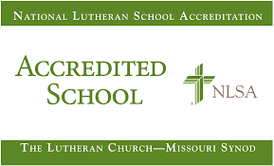
In Christ,
Nick Muench

Nick Muench
Education Administrator

